IPD File for BlackBerry
By lff0305@gmail.com

V0.1

Please get the latest version from http://code.google.com/p/bbipd/

Chapter 1 General Structure
An IPD file can be considered as a database collection. When you backup data to an IPD file from RIM Blackberry Desktop Manager, data on the phone is saved into one or more databases. Each kind of data is saved to one database. For example, all SMS(Short Message Service) data is saved in Database named by SMS Messages.

The IPD file contains the following part:
The file header : The header of the IPD file. The signature, version data are in this part.
The Database Name Blocks: Several blocks containing the Database names.
The Database Records: Several records contain the real data.

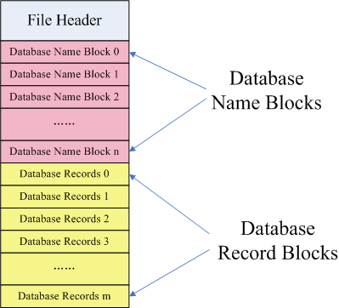

Chapter 2 File Header
File Header is a small piece of data. It has the following data:
RIM Signature
LineBreak
Database Version
Numbers of Databases in current file
Database Separator
Name | Length | Offset | Description
RIM Signature | 37 bytes | 0x0 | RIM signature:The ASCII of Inter@ctive Pager Backup/Restore File
LineBreak | 1 byte | 0x25 | 0x0A. Seems not used.
Database Version | 1 byte | 0x26 | In recent versions of BlackBerry Desktop Manager this field is 02.
Numbers of Databases | 2 byte | 0x27~0x28 | How many Databases are in this file
Database Separator | 1 byte | 0x29 | 0. Seems not used.

The following is an example from a real .IPD file.
00000000h: 49 6E 74 65 72 40 63 74 69 76 65 20 50 61 67 65 ; Inter@ctive Page
00000010h: 72 20 42 61 63 6B 75 70 2F 52 65 73 74 6F 72 65 ; r Backup/Restore
00000020h: 20 46 69 6C 65 0A 02 00 71 00 15 00 56 69 73 75 ; File...q...Visu

RIM signature LineBreak Version Number of Databases Database Seperator
Sample (1) File Header

Chapter 3 Database Name Blocks
Database Name blocks are after the Header part and they matched with DatabaseNumber value in Header part. For example, from the Sample(1), the number of Databases is 0x 00 71. So the numbers in current database will be 7 * 16 + 1 = 113:
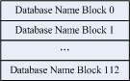
Total 113 Database Name Blocks
In each block ,the following data is saved:
Name Length
Name (Including Terminating NULL)
Name | Length | Offset From start of Database Name Block | Description
Name Length | 2 bytes | 0x0 | The length of the Database Name including NULL as Little Endian
Name | NA | 0x2 | The NAME and Terminating NULL

The following is an example from a real .IPD file.

00000000h: 49 6E 74 65 72 40 63 74 69 76 65 20 50 61 67 65 ; Inter@ctive Page
00000010h: 72 20 42 61 63 6B 75 70 2F 52 65 73 74 6F 72 65 ; r Backup/Restore
00000020h: 20 46 69 6C 65 0A 02 00 71 00 15 00 56 69 73 75 ; File...q...Visu
00000030h: 61 6C 20 56 6F 69 63 65 20 4D 61 69 6C 20 3F 3F ; al Voice Mail ??
00000040h: 00 12 00 50 69 6E 79 69 6E 20 49 4D 20 6F 70 74 ; ...Pinyin IM opt
00000050h: 69 6F 6E 73 00 18 00 41 70 70 6C 69 63 61 74 69 ; ions...Applicati
00000060h: 6F 6E 20 50 65 72 6D 69 73 73 69 6F 6E 73 00 16 ; on Permissions..
15 00 : Name Length 56 69 : Name
Sample (2) Database Name Blocks

This example shows 3 Database Names:
(1) : Length = 0x 00 15 = 21 (In file it is 0x 15 00 and it is saved as Little Endian. So when converting to an int, it should be 0x 00 15)
Name = Visual Voice Mail ??\0 (20 characters, 1 terminating NULL)
(2) : Length = 0x 00 12 = 18
Name = Pinyin IM options\0 (17 characters, 1 terminating NULL)
(3) : Length = 0x 00 18 = 24
Name=Application Permissions\0 (23 characters, 1 terminating NULL)

